**Project**

**Step 1: Initialize new Angular project:** Now, let’s start with creating an angular app at first. Here, we will be creating a simple Weather App. To do so, firstly, create a new Angular App and navigate inside the project directory using the following commands.

ng new weather-app

cd weather-app

**Step 2: Adding Bootstrap Links:** We will be using Bootstrap for styling while developing our frontend. Add following links in the *index.html* file of your project.

*<link href=”https://cdn.jsdelivr.net/npm/bootstrap@5.0.0-beta3/dist/css/bootstrap.min.css” rel=”stylesheet” integrity=”sha384-eOJMYsd53ii+scO/bJGFsiCZc+5NDVN2yr8+0RDqr0Ql0h+rP48ckxlpbzKgwra6″ crossorigin=”anonymous”>  
<script src=”https://cdn.jsdelivr.net/npm/bootstrap@5.0.0-beta3/dist/js/bootstrap.bundle.min.js” integrity=”sha384-JEW9xMcG8R+pH31jmWH6WWP0WintQrMb4s7ZOdauHnUtxwoG2vI5DkLtS3qm9Ekf” crossorigin=”anonymous”></script>*

**Step 3: OpenWeatherMap API for getting weather data:** For getting live data of weather, we will be using [openweathemap](http://openweathermap.org/api" \t "_blank) API. Get an API key by creating your account.

**Step 4: Developing the UI for WeatherApp:** Create an angular component named **weather**and angular service named **API** by running the following commands:

ng generate component components/weather

ng generate service services/API

Now, paste the following codes in their respective files.

* weather.component.ts

|  |
| --- |
| import { Component, OnInit } from '@angular/core';  import { WeatherService }       from 'src/app/services/weather.service';    @Component({    selector: 'app-weather',    templateUrl: './weather.component.html',    styleUrls: ['./weather.component.css'],  })  export class WeatherComponent implements OnInit {    city: any = '';    country: any = '';    weather: any = null;      constructor(private     \_weatherService: WeatherService) {}      ngOnInit(): void {}      getDate(str: string) {      return str.split(' ')[0];    }      getTime(str: string) {      return str.split(' ')[1];    }      displayWeather() {      this.\_weatherService    .getWeather(this.city, this.country)    .subscribe(        (data) => (this.weather = data),        (err) => console.log(err)      );    }  } |

* weather.component.html

|  |
| --- |
| <div class="container-fluid">    <div class="input card">      <div class="mb-4">        <label for="city" class="form-label">          City<span class="text-danger">\*          </span>        </label>        <input type="text" class="form-control"               name="city" id="city" [(ngModel)]="city"/>      </div>      <div class="mb-1">        <label for="country" class="form-label">          Country<span class="text-danger">\*          </span></label>        <input type="text" class="form-control"               name="country" id="country"               [(ngModel)]="country"/>      </div>      <div class="text-center mt-4">        <button type="submit" class="btn btn-primary"                (click)="displayWeather()">          Get Weather</button>      </div>    </div>      <div class="row" \*ngIf="weather"         [(ngModel)]="weather">      <div class="col-md-3" \*ngFor="let wth of weather.list">        <div class="weather-info">          <div class="d-flex justify-content-between">            <div class="info-date">              <h1>{{ wth.dt\_txt | date: "shortTime" }}</h1>              <span>{{ getDate(wth.dt\_txt) | date }}</span>              <span class="weather-city">{{ city }},                {{ country }}</span>            </div>              <div class="info-weather">              <div class="weather-wrapper">                <span class="weather-temperature">                  {{ wth.main.temp - 273.15 | number: "1.1-1" }}°C                </span>                <div class="weather-type">                  <img src=     "<https://openweathermap.org/img/wn/>{{wth.weather[0].icon}}@2x.png"                    width="64px" height="64px"                       alt="Weather Icon"/>                </div>                <br />              </div>              <span class="weather-description">                {{ wth.weather[0].description | titlecase }}              </span>            </div>          </div>          <div class="d-flex justify-content-between mt-3">            <div class="humidity"><img src="" alt="">              Humidity {{ wth.main.humidity }}%</div>            <div class="wind">              <i class="fas fa-wind"></i>Wind              {{ wth.wind.speed }} km/h            </div>            <div class="pressure">Pressure              {{ wth.main.pressure }}</div>          </div>        </div>      </div>    </div>  </div> |

* weather.component.css

|  |
| --- |
| .col-md-3 {    margin: 5px auto;  }    .input {    margin: 2% 25%;    padding: 2% 2.5%;    font-size: 16px;    box-shadow: 0 4px 8px 0 rgba(0, 0, 0, 0.2);    transition: 0.3s;  }    input {    padding: 10px 12px;  }    .weather-info {    width: 100%;    height: 100%;    padding: 20px 20px;    border-radius: 8px;    border: 2px solid #fff;    box-shadow: 0 0 4px rgba(255, 255, 255, 0.3);    background: linear-gradient(to right, #00a4ff, #0072ff);    transition: transform 0.2s ease;    color: whitesmoke;  }    .info-date {    display: flex;    flex-direction: column;    justify-content: center;  }    .info-date h1 {    margin-bottom: 0.65rem;    font-size: 2rem;    letter-spacing: 2px;  }    .info-weather {    display: flex;    flex-direction: column;    align-items: flex-end;    justify-content: center;    text-align: right;  }    .weather-wrapper {    display: flex;    align-items: center;    justify-content: flex-end;    width: 100%;  }  @keyframes animation-icon {    from {      transform: scale(1);    }    to {      transform: scale(1.2);    }  }    .weather-type {    display: inline-block;    width: 48px;    height: 48px;    transition: all 0.2s ease-in;    animation: animation-icon 0.8s infinite;    animation-timing-function: linear;    animation-direction: alternate;  }  .weather-temperature {    font-size: 1.5rem;    font-weight: 800;  }    .weather-description {    margin-top: 1rem;    font-size: 20px;    font-weight: bold;  }    .weather-city {    margin-top: 0.25rem;    font-size: 16px;  }    .wind i {    margin: 10px;  } |

* weather.service.ts

|  |
| --- |
| import { Injectable } from '@angular/core';  import { HttpClient } from '@angular/common/http';    @Injectable({    providedIn: 'root',  })  export class WeatherService {    private readonly apiKey: string = <your API key>;      constructor(private \_http: HttpClient) {}      getWeather(city: string, country: string) {      const apiUrl =   `https://api.openweathermap.org/data/2.5/forecast?q=${city},${country}&appid=${this.apiKey}`;      return this.\_http.get(apiUrl);    }  } |

Now call the weather component in **app.component.html**

<app-weather></app-weather>

**Output:**



**Step 5: Converting to the angular app to PWA:** Converting your Angular app to PWA is easy using Angular CLI. Navigate to your project’s folder. Now, run the following command to add PWA features.

ng add @angular/pwa

The above command adds the following new files:

1. Manifest file named manifest.webmanifest for PWA information
2. ngsw-config.json file for configuring the service worker
3. Default icons with many sizes in the assets/icons directory (these icons can be changed later)
4. Service worker using the @angular/service-worker package

Now, let us take a look at what each file does.

**manifest.webmanifest**

This file contains the name of the application, theme, and background color, and various sizes of icons. This configuration is applied when you add the app to the mobile it creates a web view by adding the name and icons to the app list and when the app is run the background and theme colors are applied.

* Javascript

|  |
| --- |
| {    "name": "weather-app",    "short\_name": "weather-app",    "theme\_color": "#1976d2",    "background\_color": "#fafafa",    "display": "standalone",    "scope": "./",    "start\_url": "./",    "icons": [      {        "src": "assets/icons/icon-72x72.png",        "sizes": "72x72",        "type": "image/png",        "purpose": "maskable any"      },      {        "src": "assets/icons/icon-96x96.png",        "sizes": "96x96",        "type": "image/png",        "purpose": "maskable any"      },      {        "src": "assets/icons/icon-128x128.png",        "sizes": "128x128",        "type": "image/png",        "purpose": "maskable any"      },      {        "src": "assets/icons/icon-144x144.png",        "sizes": "144x144",        "type": "image/png",        "purpose": "maskable any"      },      {        "src": "assets/icons/icon-152x152.png",        "sizes": "152x152",        "type": "image/png",        "purpose": "maskable any"      },      {        "src": "assets/icons/icon-192x192.png",        "sizes": "192x192",        "type": "image/png",        "purpose": "maskable any"      },      {        "src": "assets/icons/icon-384x384.png",        "sizes": "384x384",        "type": "image/png",        "purpose": "maskable any"      },      {        "src": "assets/icons/icon-512x512.png",        "sizes": "512x512",        "type": "image/png",        "purpose": "maskable any"      }    ]  } |

**ngsw-config** The presence of this file, one will be able to manage a wide variety of different things associated with PWA. This is where we cache the API endpoint.

* Javascript

|  |
| --- |
| {   "$schema": "./node\_modules/@angular/service-worker/config/schema.json",   "index": "/index.html",   "assetGroups": [     {       "name": "app",       "installMode": "prefetch",       "resources": {         "files": [           "/favicon.ico",           "/index.html",           "/manifest.webmanifest",           "/\*.css",           "/\*.js"         ]       }     },     {       "name": "assets",       "installMode": "lazy",       "updateMode": "prefetch",       "resources": {         "files": [           "/assets/\*\*",           "/\*.(eot|svg|cur|jpg|png|webp|gif|otf|ttf|woff|woff2|ani)"         ]       }     }   ]  } |

**Step 6: Build our Angular App for production environment:**

ng build --prod

After running the above command, our build folder is created inside dist/weather-app. Now, move to the build folder with cd dist/weather-app.

cd dist/weather-app

Install **http-server** package globally using NPM.

npm install -g http-server

**Step 7: Add our Weather App icon on the desktop to launch:** Once you will launch the angular app in the browser, a download icon will come up at the right side of URL bar as follows:

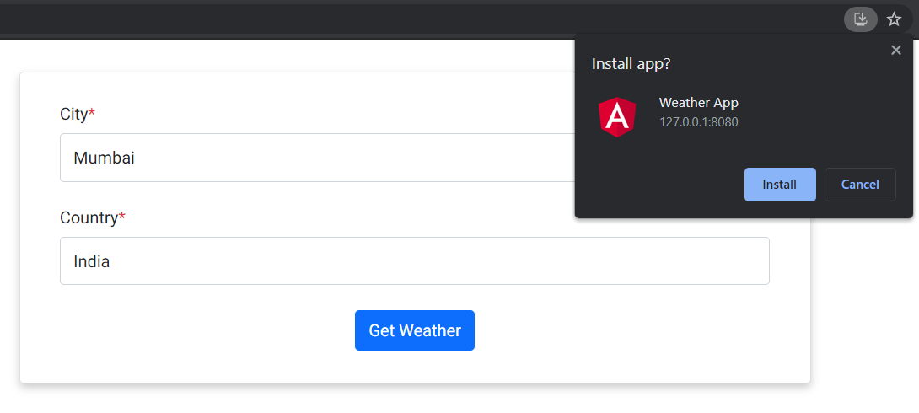

*Install Weather App*

Click on **Install** button to add the icon on Desktop for launching the app. Now, you click on the app icon created on the Desktop. You will see the following screen. (**Note:** When you click on the icon, it will not open in browser)

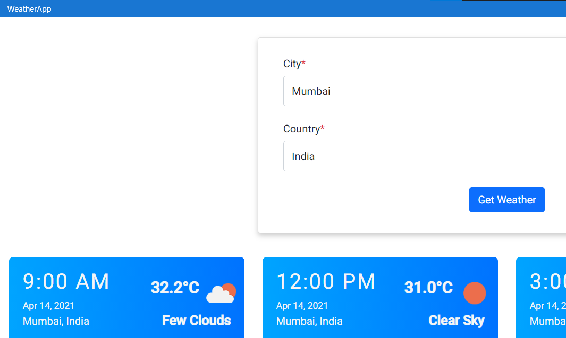

*Launching App from Desktop (any device)*

Uninstalling PWA is easy. Just click the three dots in top-nav and then click “Uninstall Weather App”.

